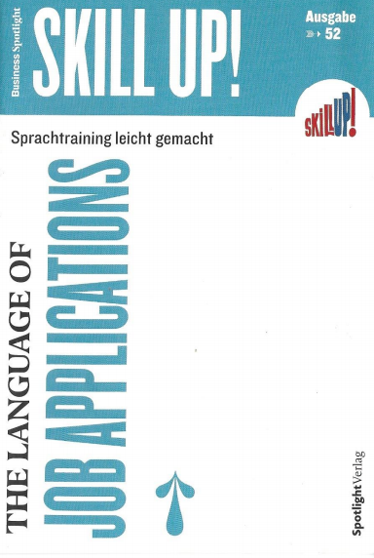
Show off your skills
Knowledge check
1. Replace each German word (in italics) in the sentences below with the correct English word. (4)
A. With your Klicken oder tippen Sie hier, um Text einzugeben. ( umfangreiches) knowledge of the Austrian Agriculture, you’d be a perfect fit for the job.
B. As an Klicken oder tippen Sie hier, um Text einzugeben. (erfahrener) project manager with a background in......
C. I played an active role in the Klicken oder tippen Sie hier, um Text einzugeben. phase (Gründungsphase).
D. If you can Klicken oder tippen Sie hier, um Text einzugeben. (beweisen) your knowledge of English, you should add it to your CV.
E. I would be Klicken oder tippen Sie hier, um Text einzugeben. (zur Verfügung stehen) for interview at your convenience.
F. My salary expectations are Klicken oder tippen Sie hier, um Text einzugeben. (imEinklang sein mit) my qualifications and education.
G. Klicken oder tippen Sie hier, um Text einzugeben. (Ich freue mich ) hearing from you at your earliest convenience.
H. I have a proven track record of developing high-quality content for technical and non-technical Klicken oder tippen Sie hier, um Text einzugeben. (Zielgruppe/Pubikum).
2. Translate the German word in English and vice versa (8)
German | English
Stellenbeschreibung | Klicken oder tippen Sie hier, um Text einzugeben.
in etwas Erfolg haben | Klicken oder tippen Sie hier, um Text einzugeben.
Führungspersönlichkeit | Klicken oder tippen Sie hier, um Text einzugeben.
eine Bewerbung einreichen | Klicken oder tippen Sie hier, um Text einzugeben.
etwas einführen/einrichten | Klicken oder tippen Sie hier, um Text einzugeben.
mit Stolz auf etwas verweisen | Klicken oder tippen Sie hier, um Text einzugeben.
wenn es Ihnen passt | Klicken oder tippen Sie hier, um Text einzugeben.
aufgabenübergreifend | Klicken oder tippen Sie hier, um Text einzugeben.
English | German
announcement | Klicken oder tippen Sie hier, um Text einzugeben.
form | Klicken oder tippen Sie hier, um Text einzugeben.
name-drop somebody | Klicken oder tippen Sie hier, um Text einzugeben.
spellcheck something | Klicken oder tippen Sie hier, um Text einzugeben.
employment history | Klicken oder tippen Sie hier, um Text einzugeben.
considerable knowledge | Klicken oder tippen Sie hier, um Text einzugeben.
resourceful | Klicken oder tippen Sie hier, um Text einzugeben.
familiar with something | Klicken oder tippen Sie hier, um Text einzugeben.

3. Complete the statements with the correct preposition and translate the sentences from English into German. (6)
A. I would like to apply Klicken oder tippen Sie hier, um Text einzugeben. the position.
Klicken oder tippen Sie hier, um Text einzugeben.

B. Deal Klicken oder tippen Sie hier, um Text einzugeben.costumer complaints in a timely and friendly manner.
Klicken oder tippen Sie hier, um Text einzugeben.

C. I am excited Klicken oder tippen Sie hier, um Text einzugeben.the prospect of working for your firm.
Klicken oder tippen Sie hier, um Text einzugeben.

D. I am impressed Klicken oder tippen Sie hier, um Text einzugeben. your company’s portfolio.
Klicken oder tippen Sie hier, um Text einzugeben.

E. As I worked ten months in Ireland, I am now fluent Klicken oder tippen Sie hier, um Text einzugeben. English.
Klicken oder tippen Sie hier, um Text einzugeben.

F. I specialize Klicken oder tippen Sie hier, um Text einzugeben. helping clients resolve technical issues.
Klicken oder tippen Sie hier, um Text einzugeben.

