Student’s version

Procedure step 1 and 2

Have a look at the word cloud. First make sure that you understand all the words. Look up any important words in an online dictionary. Then get in pairs and speculate what the lesson will be about.

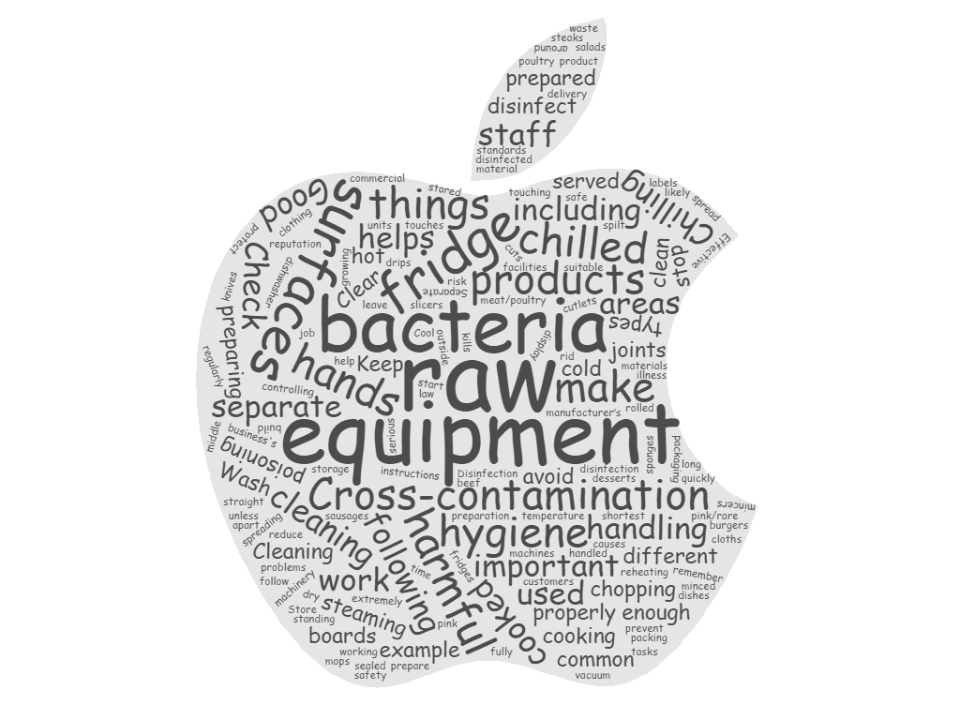
Procedure step 3

Food hygiene for businesses
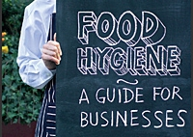

Good food hygiene is essential for you to make or sell food that is safe to eat. It is very important for you and your staff to understand what good food hygiene is.

Good food hygiene: the 4 Cs
Good food hygiene helps you to:
- Obey the law
- Reduce the risk of food poisoning among your customers
- Protect your business's reputation
Good food hygiene is all about controlling harmful bacteria, which can cause serious illness. BAC (foodborne bacteria) could make you and those you care about sick. In fact, even though you can’t see BAC - or smell him, or feel him - he and millions more like him may have already invaded the food you eat. But you have the power to fight BAC! Foodborne illness can strike anyone. Some people are at a higher risk for developing foodborne illness, including pregnant women, young children, older adults and people with weakened immune systems. For these people the following four simple steps are critically important:
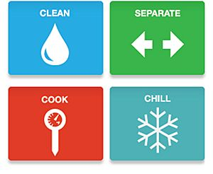
The four main things to remember for good hygiene are:
- Cross-contamination (Separate)
- Cleaning
- Chilling
- Cooking

These are known as the 4 Cs. They will help you prevent the most common food safety problems.
Procedure step 4
Group 1
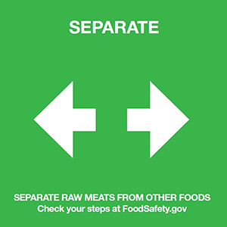
Form 4 groups. The first group reads part 1, the second group reads part 2, the third group reads part 3 and the fourth group reads part 4. While reading summarise the most important facts in a mind map. Get back to the text and write down 3 to 4 WH-questions. Provide the correct answer to your questions.
Then get together with a person who has read the same part as you. Compare your findings and add any missing information.
Finally, get in groups of four and inform each other about the part of the text you have read.
Write the questions on the board.

Cross-contamination is when bacteria are spread between food, surfaces or equipment. It is most likely to happen when raw food touches (or drips onto) ready-to-eat food, equipment or surfaces. Don’t cross-contaminate. Cross-contamination is how bacteria can be spread. When handling raw meat, poultry, seafood and eggs, keep these foods and their juices away from ready-to-eat foods. Always start with a clean scene — wash hands with warm water and soap. Wash cutting boards, dishes, countertops and utensils with hot soapy water.
Cross-contamination is one of the most common causes of food poisoning. Do the following things to avoid it:
- Clean and disinfect work surfaces, chopping boards and equipment thoroughly before you start preparing food and after you have used them to prepare raw food.
- Use different equipment (including chopping boards and knives) for raw meat/poultry and ready-to-eat food unless they can be heat disinfected in, for example, a commercial dishwasher.
- Wash your hands before preparing food.
- Wash your hands thoroughly after touching raw food.
- Keep raw and ready-to-eat food apart at all times, including packaging material for ready-to-eat food.
- Store raw food below ready-to-eat food in the fridge. If possible, use separate fridges for raw and ready-to-eat food.
- Provide separate working areas, storage facilities, clothing and staff for the handling of ready-to-eat food.
- Use separate machinery and equipment, such as vacuum packing machines, slicers and mincers, for raw and ready-to-eat food.
- Separate cleaning materials, including cloths, sponges and mops, should be used in areas where ready-to-eat foods are stored, handled and prepared.
- Make sure that your staff know how to avoid cross-contamination.

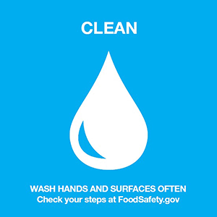
Group 2
Form 4 groups. The first group reads part 1, the second group reads part 2, the third group reads part 3 and the fourth group reads part 4. While reading summarise the most important facts in a mind map. Get back to the text and write down 3 to 4 WH-questions. Provide the correct answer to your questions.
Then get together with a person who has read the same part as you. Compare your findings and add any missing information.
Finally, get in groups of four and inform each other about the part of the text you have read.
Write the questions on the board.
Effective cleaning gets rid of bacteria on hands, equipment and surfaces. So it helps to stop harmful bacteria from spreading onto food.
You should do the following things: Wash hands and surfaces often Bacteria can be spread throughout the kitchen and get onto hands, cutting boards, utensils, counter tops and food. To fight BAC always:
- Make sure that all your staff wash and dry their hands thoroughly before handling food.
- Clean and disinfect food areas and equipment between different tasks, especially after handling raw food.
- Clear and clean as you go. Clear away used equipment, spilt food etc. as you work and clean work surfaces thoroughly.
- Use cleaning and disinfection products that are suitable for the job, and follow the manufacturer’s instructions.
- Disinfection products should meet BS EN standards. Check product labels for either of these codes: BS EN 1276 or BS EN 13697.
- Do not let food waste build up.
- Wash your hands with warm water and soap for at least 20 seconds before and after handling food and after using the bathroom, changing diapers and handling pets.
- Wash your cutting boards, dishes, utensils and counter tops with hot soapy water after preparing each food item and before you go on to the next food.
- Consider using paper towels to clean up kitchen surfaces. If you use cloth towels wash them often in the hot cycle of your washing machine.
- Rinse fresh fruits and vegetables under running tap water, including those with skins and rinds that are not eaten.
- Rub firm-skin fruits and vegetables under running tap water or scrub with a clean vegetable brush while rinsing with running tap water.

