The Importance of Crop Rotations

- Read the definitions of crop rotation and monoculture below! (10min)
- Are there any words you don’t understand? List them on the last page!
- Use the words from the box to fill in the missing words!
What is a crop rotation?
A crop rotation is a series of different crops planted in the same field in a defined order (i.e., maize-cotton-sunflowers or maize-soybeans).
Monoculture is the repeated planting of the same crop in the same field year after year.
repeated – field – year – crops – order – year

- What are the correct words in the text “What problems occur with monocultures”? (10min)
- Are there any words you do not understand? List them on the last page!
- Choose the correct options in the following text!
What problems occur with monocultures?
In monocultures, increases in crop-specific pests and diseases/deformations are observed over time. Continuously growing the same crop will tend to exploit/nourish the same soil root zone, which can lead to a decrease in available soil organisms/nutrients for plant growth and to a decrease in root/insect development.
- Watch the video: “Why Do Farmers Rotate Crops? - Farm Basics” (15min) (https://www.youtube.com/watch?v=3QLYFg4NIN8 )
- List the words you don’t understand on the last page!
- Watch the video again and note down the benefits of crop rotations! Discuss your key terms together!
Benefits of crop rotations:
  - Helps avoid problems with insects and diseases
  - Improves weed control
  - Nutrients: new crops profit from the nitrogen residues from the last crop
  - Spreads out the workload

- In addition to the video, what are some other benefits of crop rotations you know about? (5min)

- What diseases and pests do you know which can be avoided by crop rotations? (If necessary, watch the video again!) (5min)
Western corn rootworm (Diabrotica virgifera virgifera), Nematodes, Sclerotinia White Mold
- Take a book about crop production (i.e., “Pflanzenbau 1 – Grundlagen”) or do research on the internet to find out the recommended cultivation breaks of the following crops! What could be possible reasons for the break? (15min)
Crop | Years of Break | Possible Reason(s)
Wheat, Barley | 2-3
Potato | 3-4
Soybeans | 4-5
Sugarbeet | 4-5
Sunflowers | 5-6
Rapeseed | 3-4

- Rules for planning your crop rotation. (15min)
- Read the rules for crop rotation!
- Are there any words you do not understand? List them on the last page!
- Group work: Build a group of four, mark the important keywords and compare your results!
- Do not plant the same family of plants in the same spot 2 years in a row (because insects, nematodes, and pathogens are all attracted to specific kinds of plants so by mixing up the plant families you plant in a spot it helps prevent infection from pests).
- Do not grow the same kind of plant in the same spot 2 years in a row.
- Follow deep-rooted plants with shallow rooted plants and vice versa.
- When growing high yielding plants alternate them with low yielding plants that are very resistant to diseases.
- Alternate high effort plants with low effort plants.
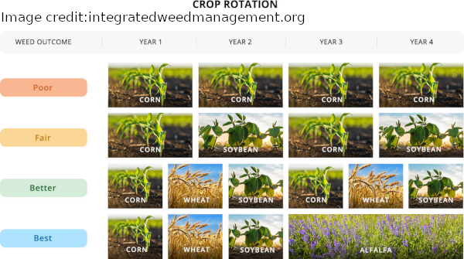
- Preferably, have a 4-year cycle because many soil borne diseases stay in the soil for 3 years. Even if the plants are not affected, you can avoid the infection.
- It is good to have cover crops as part of your crop rotation as many of them build up the soil and some of them deter pests.
- The more crop rotation crops you cultivate, the better. (As illustrated in the image below!)
- Plan two crop rotations with four parts! Present the result of your groupwork in front of your classmates! Explain the reasons of your selections! (15min)
Your Own Crop Rotation:

Vocabulary:
Word | Description

List of references:
https://alaskamastergardener.community.uaf.edu/2019/12/06/crop-rotation/
https://boku.ac.at/fileadmin/data/H03000/H73000/H73300/PJ/Mozambique/CIMMYT_ExtBulletins02.pdf
https://www.youtube.com/watch?v=3QLYFg4NIN8
Pflanzenbau 1 – Grundlagen, Leopold Stocker Verlag, 2022

