The Importance of Crop Rotations

- Read the definitions of crop rotation and monoculture below.
- Are there any words you do not understand? List them on the last page.
- Use the words from the box to fill in the missing words.
What is a crop rotation?
A crop rotation is a series of different _________ planted in the same __________in a defined __________ (i.e., maize-cotton-sunflowers or maize-soybeans).
Monoculture is the ________ planting of the same crop in the same field _____ after _____.
repeated – field – year – crops – order – year

- What are the correct words in the text “What problems occur with monocultures”?
- Are there any words you do not understand? List them on the last page.
- Choose the correct options in the following text.
What problems occur with monocultures?
In monocultures, increases in crop-specific pests and diseases/deformations are observed over time. Continuously growing the same crop will tend to exploit/nourish the same soil root zone, which can lead to a decrease in available soil organisms/nutrients for plant growth and to a decrease in root/insect development.
- Watch the video: “Why Do Farmers Rotate Crops? - Farm Basics” (https://www.youtube.com/watch?v=3QLYFg4NIN8 )
- List the words you do not understand on the last page.
- Watch the video again and note down the benefits of crop rotations. Discuss your key terms together.

Benefits of crop rotations:
  - ___________________________________________________________
  - ___________________________________________________________
  - ___________________________________________________________
  - ___________________________________________________________

- In addition to the video, what are some other benefits of crop rotations you know about?

- What diseases and pests do you know which can be avoided by crop rotations? (If necessary, watch the video again.)

- Take a book about crop production (i.e., “Pflanzenbau 1 – Grundlagen”) or do research on the internet to find out the recommended cultivation breaks of the following crops. What could be possible reasons for the break?
Crop | Years of Break | Possible Reason(s)
Wheat, Barley
Potato
Soybeans
Sugarbeet
Sunflowers
Rapeseed

- Rules for planning your crop rotations.
- Read the rules for crop rotations.
- Are there any words you do not understand? List them on the last page.
- Groupwork: Build a group of four, mark the most important keywords and compare your results.
- Do not plant the same family of plants in the same spot 2 years in a row (because insects, nematodes, and pathogens are all attracted to specific kinds of plants so by mixing up the plant families you plant in a spot it helps prevent infection from pests).
- Do not grow the same kind of plant in the same spot 2 years in a row.
- Follow deep-rooted plants with shallow rooted plants and vice versa.
- When growing high yielding plants alternate them with low yielding plants that are very resistant to diseases.
- Alternate high effort plants with low effort plants.
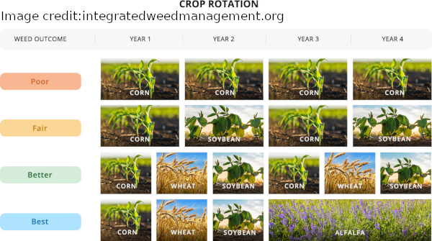
- Preferably, have a 4-year cycle because many soil borne diseases stay in the soil for 3 years. Even if the plants are not affected, you can avoid the infection.
- It is good to have cover crops as part of your crop rotation as many of them build up the soil and some of them deter pests.
- The more crop rotation crops you cultivate, the better. (As illustrated in the image below.)
- Plan two crop rotations with four parts. Present the result of your groupwork in front of your classmates. Explain the reasons of your selections.
Your Own Crop Rotation:

Vocabulary:
Word | Description

List of references:
https://alaskamastergardener.community.uaf.edu/2019/12/06/crop-rotation/
https://boku.ac.at/fileadmin/data/H03000/H73000/H73300/PJ/Mozambique/CIMMYT_ExtBulletins02.pdf
https://www.youtube.com/watch?v=3QLYFg4NIN8
Pflanzenbau 1 – Grundlagen, Leopold Stocker Verlag, 2022

