Christmas Truce 1914
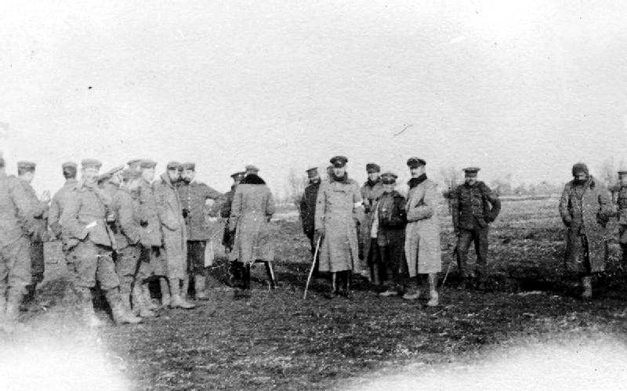
British and German troops meeting in No-Mans's Land during the unofficial truce. (Robson Harold B, Imperial War Museums, Public Domain)
1. Read the chapters „Background“, „Fraternisation“ and „Christmas 1914“ on following Wikipedia-entry: https://en.wikipedia.org/wiki/Christmas_truce
2. Translate following words into German:
ceasefire | Waffenstillstand | burial | Begräbnis
troops | Truppen | lamentable desire | klägliche Begierde
battle | Schlacht / Gefecht | christmas carols | Weihnachtslieder
digging trenches | Schützengräben graben | no man´s land | Niemandsland
peace initiatives | Friedensinitiativen | joint services | gemeinsame Gottesdienste
fraternisation | Verbrüderungen | Boxing Day | Geschenketage, 26. Dezember

3. Imagine you were a british soldier on these frontlines at Christmas 1914. Write a postcard to your family or a diaryentry for your own about your experiences.
Informations about field post / military postal service:
Field post was very important in World War I. Even in the 19th century prussian Field Marshal and Chief of General Staff Graf Helmuth von Moltke is credited with saying: „Ohne Feldpost ist ein Krieg nicht zu führen.“ Censorship was initially implemented since the beginning of the war in Austro-Hungarian field post. The totally censorship had to be abandoned even during 1914 and from 1915 on field post were only checked randomly.
Source: https://ww1.habsburger.net/de/kapitel/kriegsfuehrung-mittels-feldpost
4. Sainsbury´s is one of the largest supermarket chains in the United Kingdom. 2014 at the 100th anniversary of the Christmas Truce from 1914 Sainsbury´s made a Christmas advertisement. This advertisement is not uncontroversial.
Watch the ad at following link: https://video.link/w/38qRc
Make some notices for a following discussion about these questions:
Is war pictured here glossed over?
Is it unethical to make an advertisment with war-content?
Does the slogan „Christmas is for sharing!“ suggests that „Sharing is buying!“?

5. Discuss your outcomes with your classmates.
A critical article from Ally Fogg: The Guardian „Sainsbury’s Christmas ad is a dangerous and disrespectful masterpiece“ (https://www.theguardian.com/commentisfree/2014/nov/13/sainsburys-christmas-ad-first-world-war )

Optional materials:
A short movie on Youtube from Union of European Football Associations (UEFA) https://www.youtube.com/watch?v=DYv6dHy5TJE Football Stars are reading from soldiers notes.
The movie „Merry Christmas“ (2005, Director: Christian Carion)

