Christmas Truce 1914
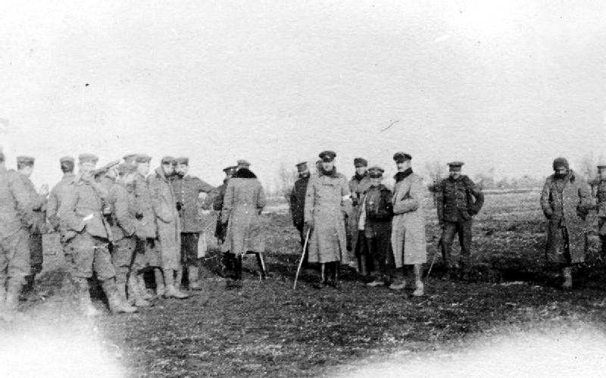
British and German troops meeting in No-Mans's Land during the unofficial truce. (Robson Harold B, Imperial War Museums, Public Domain)
1. Read the chapters „Background“, „Fraternisation“ and „Christmas 1914“ on following Wikipedia-entry: https://en.wikipedia.org/wiki/Christmas_truce
2. Translate following words into German:
ceasefire |  | burial
troops |  | lamentable desire
battle |  | christmas carols
digging trenches |  | no man´s land
peace initiatives |  | joint services
fraternisation |  | Boxing Day

3. Imagine you were a British soldier on these frontlines at Christmas 1914. Write a postcard to your family or a diary entry about your experiences.
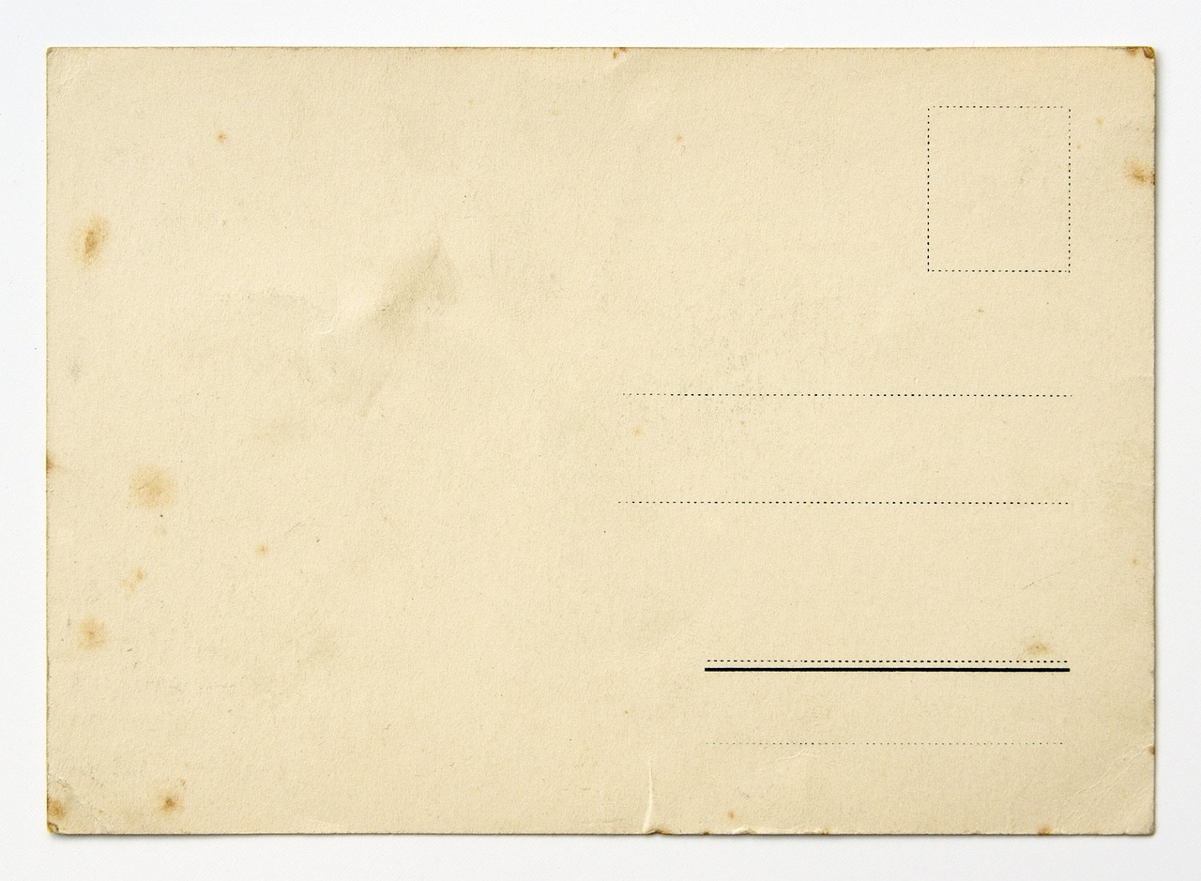
4. Sainsbury´s is one of the largest supermarket chains in the United Kingdom. 2014 at the 100th anniversary of the Christmas Truce from 1914 Sainsbury´s made a Christmas advertisement. This advertisement is not uncontroversial.
Watch the ad: https://video.link/w/38qRc
Make some notes for the following discussion about these questions:
Is war pictured here glossed over?
Is it unethical to make an advertisement with war content?
Does the slogan “Christmas is for sharing!” suggest that “Sharing is buying!“?

5. Discuss your outcomes with your classmates.

